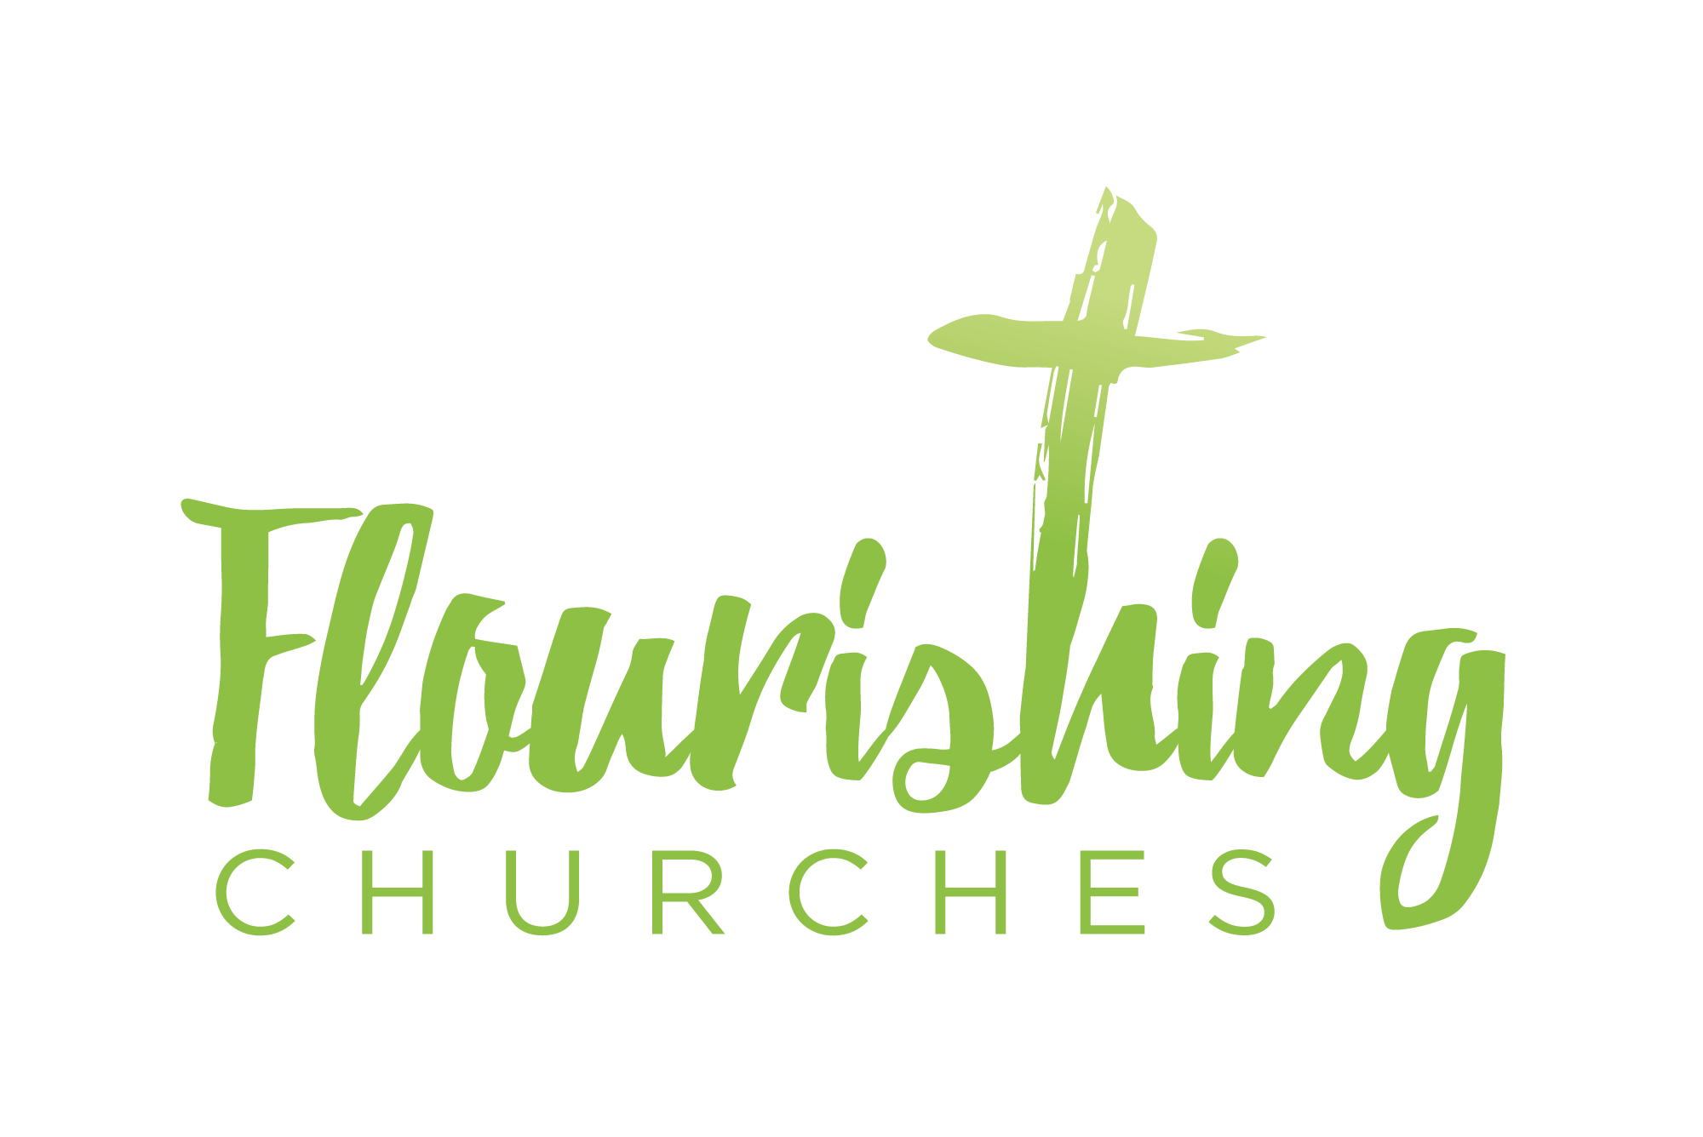
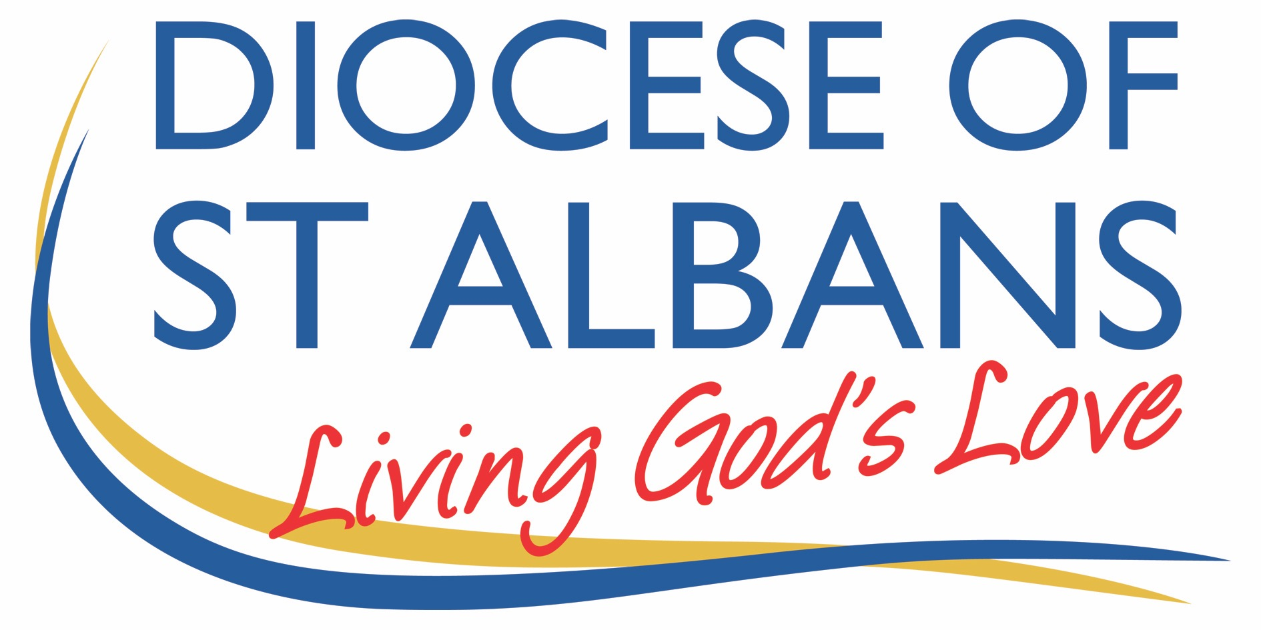

The Second Sunday of Easter – 11th April 2021

Welcome to Praying Together but Separately

welcome and introduction

hymn
1 Alleluia, Alleluia!
hearts to heaven and voices raise;
sing to God a hymn of gladness,
sing to God a hymn of praise:
he who on the Cross a victim
for the world's salvation bled,
Jesus Christ the King of glory,
now is risen from the dead.
2 Christ is risen, Christ the first-fruits
of the holy harvest field,
which will all its full abundance
at his second coming yield;
then the golden ears of harvest
will their heads before him wave,
ripened by his glorious sunshine,
from the furrows of the grave.
3 Christ is risen, we are risen;
shed upon us heavenly grace,
rain and dew, and gleams of glory
from the brightness of thy face;
that we, with our hearts in heaven,
here on earth may fruitful be,
and by angel-hands be gathered,
and be ever, Lord, with thee.
4 Alleluia, Alleluia,
glory be to God on high;
Alleluia to the Saviour,
who has gained the victory;
Alleluia to the Spirit,
fount of love and sanctity;
Alleluia, Alleluia,
to the Triune Majesty.
Christopher Wordsworth (1807-1885)

Gathering Before God
As we settle before God, you may wish to light a candle as we will light the Paschal candle in church, to remind us of Jesus, the Light of the World.

Alleluia, Christ is Risen!
He is Risen indeed, Alleluia!

Jesus stand among us in your risen power,
Let this time of worship be a hallowed hour. Amen.

Prayer of the Day
Risen Christ, for whom no door is locked, no entrance barred: open the doors of our hearts, that we may seek the good of others and walk the joyful road of sacrifice and peace, to the praise of God the Father. Amen

bible reading

Acts 4: 32-35
A reading from the Acts of the Apostles

The whole group of those who believed were of one heart and soul, and no one claimed private ownership of any possessions, but everything they owned was held in common. With great power the apostles gave their testimony to the resurrection of the Lord Jesus, and great grace was upon them all. There was not a needy person among them, for as many as owned lands or houses sold them and brought the proceeds of what was sold. They laid it at the apostles’ feet, and it was distributed to each as any had need.

This is the word of the Lord: Thanks be to God

Psalm 133
R: Mercy and truth are met together,
righteousness and peace have kissed each other.

Behold how good and pleasant it is to dwell together in unity.
It is like the precious oil upon the head,
Running down upon the beard,
Even on Aaron’s beard,
Running down upon the collar of his clothing.
R: Mercy and truth are met together,
righteousness and peace have kissed each other.

It is like the dew of Hermon
Running down upon the hills of Zion.
For there the Lord has promised his blessing:
Even life for evermore.
R: Mercy and truth are met together,
righteousness and peace have kissed each other.

invitation to confession
Christ our Passover lamb has been sacrificed for us.
Let us therefore rejoice by putting away all malice and evil
and confessing our sins with a sincere and true heart.
Silence is kept.

Like Mary at the empty tomb,
we fail to grasp the wonder of your presence.
Lord, have mercy. All Lord, have mercy.
Like the disciples behind locked doors,
we are afraid to be seen as your followers.
Christ, have mercy. All Christ, have mercy.
Like Thomas in the upper room,
we are slow to believe.
Lord, have mercy. All Lord, have mercy.

the absolution
May the God of love and power, forgive you and free you from your sins, heal and strengthen you by his Spirit,
and raise you to new life in Christ our Lord. All Amen.

gloria in excelsis
All Glory to God in the highest,
and peace to his people on earth.
Lord God, heavenly King,
almighty God and Father,
we worship you, we give you thanks,
we praise you for your glory.
Lord Jesus Christ, only Son of the Father,
Lord God, Lamb of God,
you take away the sin of the world:
have mercy on us;
you are seated at the right hand of the Father:
receive our prayer.
For you alone are the Holy One,
you alone are the Lord,
you alone are the Most High, Jesus Christ,
with the Holy Spirit, in the glory of God the Father. Amen.

bible readings

Second Reading: 1 john 1:1-2.2
A reading from the first letter of John
We declare to you what was from the beginning, what we have heard, what we have seen with our eyes, what we have looked at and touched with our hands, concerning the word of life - this life was revealed, and we have seen it and testify to it, and declare to you the eternal life that was with the Father and was revealed to us – we declare to you what we have seen and heard so that you also may have fellowship with us; and truly our fellowship is with the Father and with his Son, Jesus Christ. We are writing these things so that our joy may be complete.
This is the message we have heard from him and proclaim to you, that God is light; in him there is no darkness at all. If we say that we have fellowship while we are walking in darkness, we lie and do not do what is true; but if we walk in light as he himself is in the light, we have fellowship with one another, and the blood of Jesus his Son, cleanses us from all sin.
If we say that we have no sin, we deceive ourselves, and the truth is not in us. If we confess our sins, he who is faithful and just will forgive us our sins and cleanse us from all unrighteousness.
If we say that we have not sinned, we make him a liar, and his word is not in us.
My little children, I am writing these things to that you may not sin. But if anybody does sin, we have an advocate with the Father, Jesus Christ, the righteous; and he is the atoning sacrifice for our sins, and not for ours only but also for the sins of the whole world.

hymn
1 Jesus lives! thy terrors now
can, O death, no more appal us;
Jesus lives! by this we know
thou, O grave, canst not enthral us.
Alleluia.

Jesus lives! henceforth is death
but the gate of life immortal:
this shall calm our trembling breath,
when we pass its gloomy portal.
Alleluia.

Jesus lives! for us he died;
then, alone to Jesus living,
pure in heart may we abide,
glory to our Saviour giving.
Alleluia.

Jesus lives! our hearts know well,
naught from us his love shall sever;
life nor death nor powers of hell
tear us from his keeping ever.
Alleluia.
5 Jesus lives! to him the throne
over all the world is given:
may we go where he is gone,
rest and reign with him in heaven.
Alleluia.
Jesus lebt, mit ihm auch ich
Christian Fuerchtegott Gellert (1715-1769), Frances Elizabeth Cox (1812-1897)

gospel Reading: John 20.19-31
It was evening on the first day of the week, and the doors of the house where the disciples had met were locked for fear of the Jews, Jesus came and stood among them and said, ‘Peace be with you.’ After he said this, he showed them his hands and his side. Then the disciples rejoiced when they saw the Lord. Jesus said to them again, ‘Peace be with you. As the Father has sent me, so I send you.’ When he had said this, he breathed on them and said to them, ‘Receive the Holy Spirit. If you forgive the sins of any, they are forgiven them; if you retain the sins of any, they are retained.’

But Thomas (who was called the Twin), one of the twelve, was not with them when Jesus came. So the other disciples told him, ‘We have seen the Lord.’ But he said to them, ‘Unless I see the mark of the nails in his hands, and put my finger in the mark of the nails and my hand in his side, I will not believe.’

A week later his disciples were again in the house, and Thomas was with them. Although the doors were shut, Jesus came and stood among them and said, ‘Peace be with you.’ Then he said to Thomas, ‘Put your finger here and see my hands. Reach out your hand and put it in my side. Do not doubt but believe.’ Thomas answered him, ‘My Lord and my God!’ Jesus said to him, ‘Have you believed because you have seen me? Blessed are those who have not seen and yet have come to believe.’
Now Jesus did many other signs in the presence of his disciples, which are not written in this book. But these are written so that you may come to believe that Jesus is the Messiah, the Son of God, and that through believing you may have life in his name.

(Reflection
Read Acts 4.32-35. On a piece of paper make two columns. In the right-hand column write down some words that describe the disciples in this reading. Then in the left-hand column write down some words to describe the disciples at the arrest of Jesus. What was it that made the difference?

Pray that the Holy Spirit of God would fill you afresh).

Some thoughts for further Reflection:
Jesus has been killed. His disciples are frankly, terrified. They lock themselves in a room and wait for some Roman soldiers to come and arrest them and hang them on a cross until they die just as they had done with Jesus.

So, the disciples are in a room and the door is locked. We don’t know how many there were – we know that Thomas and Judas were not there, but there may have been the wider group of disciples there as well as the remaining ten.

Then Jesus appears. Not in Spirit, not as a voice from the other side, not a vision: but in a reach out and hug me kind of way; a smack one another on the back, cry into one another’s shoulders, greet one another with a holy kiss kind of way.

And then something really strange happens after Jesus, whom they have seen killed, and who is now alive again, appears in the middle of a locked room - Jesus breathes on them.
Jesus who created the world, who was there at the start, who was there when God breathed his breath into Adam – when God breathed ‘the Ruach’ (in the Hebrew), and new life happened. Here Jesus is creating new life. And as he breathes on them he says, ‘Receive the Holy Spirit.’

It was unusual, powerful, symbolic, and real (can something be a symbol and be real? If God is in involved: yes.) The lives of the disciples would never be the same.

And then Jesus said something really, really, amazing. ‘If you forgive the sins of anyone their sins are forgiven, if you do not forgive them they are not forgiven.’

This is not the same as the outpouring of the Holy Spirit at Pentecost, at the birth of the church, but it is a sign that is a full assurance of the actual event that will take place.
Who is the Holy Spirit?

We can know Jesus through reading the Bible. Using Facebook as an illustration: if I were to follow you on Facebook I would know lots about you, your family, where you went on holiday last, the things you enjoy, etc, but I wouldn’t have ever met you, so although I know all about you, I wouldn’t really know you.

We need to know Jesus in our heads, but we need to meet with Jesus in our heart and allow Jesus to shape our lives.

When Jesus is speaking to his disciples and tells them that one day he will be killed and go to his Father and prepare a place for them, he tells those disciples that it is better that he goes because he will send another counsellor like him. Exactly like him.

It is hard to imagine something better than sitting down and eating a meal with the real, physical, incarnate Jesus. Is there anything better than having a meal with the Son of God, passing him the olives and making a joke with the creator of the cosmos?

Apparently there is: and it is the Holy Spirit. We need the Holy Spirit to guide us, to enable us, to resource us, to give us courage, to energise us, to know us and to give us those spiritual gifts which the Father wishes to equip us with: faith and new understanding, and new life, for the working of His Kingdom.

Peace is forgiveness with God. Forgiveness with God is the kingdom. The church is a sign, foretaste and agent of the kingdom.

There is a broken world that needs forgiving.

If we show the world what Jesus’ forgiveness looks the world will know it; if we don’t the world won’t.

We need the Holy Spirit to help us show the world what forgiveness looks like.

And we need the Easter sermon again: Jesus died for people who have faith, people who have none, and people who are not sure.

affirmation of faith
Brothers and sisters, I ask you to profess the faith of the Church.
Do you believe and trust in God the Father?

All I believe in God, the Father almighty,
creator of heaven and earth.

Do you believe and trust in his Son Jesus Christ?
All I believe in Jesus Christ, his only Son, our Lord,
who was conceived by the Holy Spirit,
born of the Virgin Mary,
suffered under Pontius Pilate,
was crucified, died, and was buried;
he descended to the dead.
On the third day he rose again;
he ascended into heaven,
he is seated at the right hand of the Father,
and he will come to judge the living and the dead.
Do you believe and trust in the Holy Spirit?
All I believe in the Holy Spirit,
the holy catholic Church,
the communion of saints,
the forgiveness of sins,
the resurrection of the body,
and the life everlasting. Amen.

hymn
1 Now the green blade rises from the buried grain,
wheat that in the dark earth many days has lain;
love lives again, that with the dead has been:
Love is come again, like wheat that springs up green.
2 In the grave they laid him, Love whom men had slain,
thinking that he never would awake again,
laid in the earth like grain that sleeps unseen:
Love is come again, like wheat that springs up green.
3 Forth he came at Easter, like the risen grain,
he that for the three days in the grave had lain,
back from the dead my risen Lord is seen:
Love is come again, like wheat that springs up green.
4 When our hearts are wintry, grieving, or in pain,
then your touch can call us back to life again,
fields of our hearts that dead and bare have been:
Love is come again, like wheat that springs up green.
John Macleod Campbell Crum (1872-1958)
© Oxford University Press

Prayers
Blessed are you, Lord God of our salvation.
To you be praise and glory for ever.
You have delivered us from the darkness of death
through your beloved Son.
In him, light has conquered darkness;
life has triumphed over death.
He has breathed into us your life-giving Spirit.
Blessed are you, Father, Son and Holy Spirit,
our God for ever and ever.

Lord, we give you thanks for the light of the Gospel
and that it shines in our hearts.
We rejoice in the resurrection and in your saving power.
We remember all who are struggling with their faith,
those who doubt,
any who sit in darkness or who live in fear.
We bring to mind all who have fallen away from the faith,
especially any known to us.

Silence

Lord God, you are light: in you is no darkness at all.

We remember peoples and nations who feel drained
and lack energy.
We ask your blessing upon all who suffer
from poverty or oppression.
We pray for any who are separated from their loved ones
and their homes;
we remember all who are in prison.

Silence

Lord God, you are light: in you is no darkness at all.

We give thanks that you appeared in an ordinary home,
O Christ.
We ask that your presence and your peace
may be known in our homes and among our loved ones.
We bring before you homes where faith is mocked
or persecuted,
and pray for all who are struggling to remain faithful.
Silence

Lord God, you are light:in you is no darkness at all.

We think of all who are struggling with life:
homes where there is tension or lack of peace;
people who are ill and afraid of the future;
all who are lonely and facing a time of crisis.
May all know your presence and your peace.

Silence

Lord God, you are light: in you is no darkness at all.

Father, we give you thanks
for the new life that you offer to us in your Son,
for you offer us eternal life.
We come to you with confidence
and pray for friends and loved ones departed
May they know the fullness of joy in your presence and in eternal life.

Silence

Merciful Father,
accept these prayers
for the sake of your Son,
our Saviour Jesus Christ. Amen.

the peace
The risen Christ came and stood among his disciples and said,
‘Peace be with you.’
Then were they glad when they saw the Lord. Alleluia.
Alleluia. The peace of the risen Christ be always with you
All and also with you. Alleluia. Christ is risen.

musical Intro
an act of spiritual Communion
My Jesus, I believe that You
are present in the Most Holy Sacrament.
I love You above all things,
and I desire to receive You into my soul.
Since I cannot at this moment
receive You sacramentally,
come at least spiritually into my heart.
I embrace You as if You were already there
and unite myself wholly to You.
Never permit me to be separated from You. Amen.

Alleluia. Christ our Passover is sacrificed for us.
All Therefore let us keep the feast. Alleluia.

The Conclusion
Let us pray for the coming of the kingdom in the words our Saviour taught us

Our Father in heaven,
Hallowed by your name,
Your kingdom come,
Your will be done,
On earth as in heaven.
Give us today our daily bread.
Forgive us our sins
As we forgive those who sin against us.
lead us not into temptation
But deliver us from evil.
For the kingdom, the power, and the glory are yours
Now and forever. Amen.

the final hymn
1 The day of resurrection,
Earth, tell it out abroad!
the passover of gladness,
the passover of God!
From death to life eternal,
from earth up to the sky,
our God has brought us over
with hymns of victory.
2 Our hearts be pure from evil,
that we may see aright
the Lord in rays eternal
of resurrection light;
and, listening to his accents,
may hear, so calm and plain,
his own 'All hail!' and, hearing
may raise the victor strain.
3 Now let the heavens be joyful,
and earth her song begin,
the round world keep high triumph,
and all that is therein;
let all things seen and unseen
their notes of gladness blend,
for Christ the Lord is risen,
our joy that has no end.
Anastaseos hemera
John of Damascus (c.675-749) translated John Mason Neale (1818-1866)

blessing.
Alleluia. Christ is risen.
All He is risen indeed. Alleluia.

God the Father, by whose love Christ was raised from the dead,
open to you who believe the gates of everlasting life Amen.

God the Son,
who in bursting the grave has won a glorious victory,
give you joy as you share the Easter faith. Amen.

God the Holy Spirit,
whom the risen Lord breathed into his disciples,
empower you and fill you with Christ’s peace. Amen.

And the blessing of God almighty,
the Father, the Son, and the Holy Spirit,
be among you and remain with you always. Amen.

Go in Peace to Love and Serve the Lord. In the name of Christ, Amen

