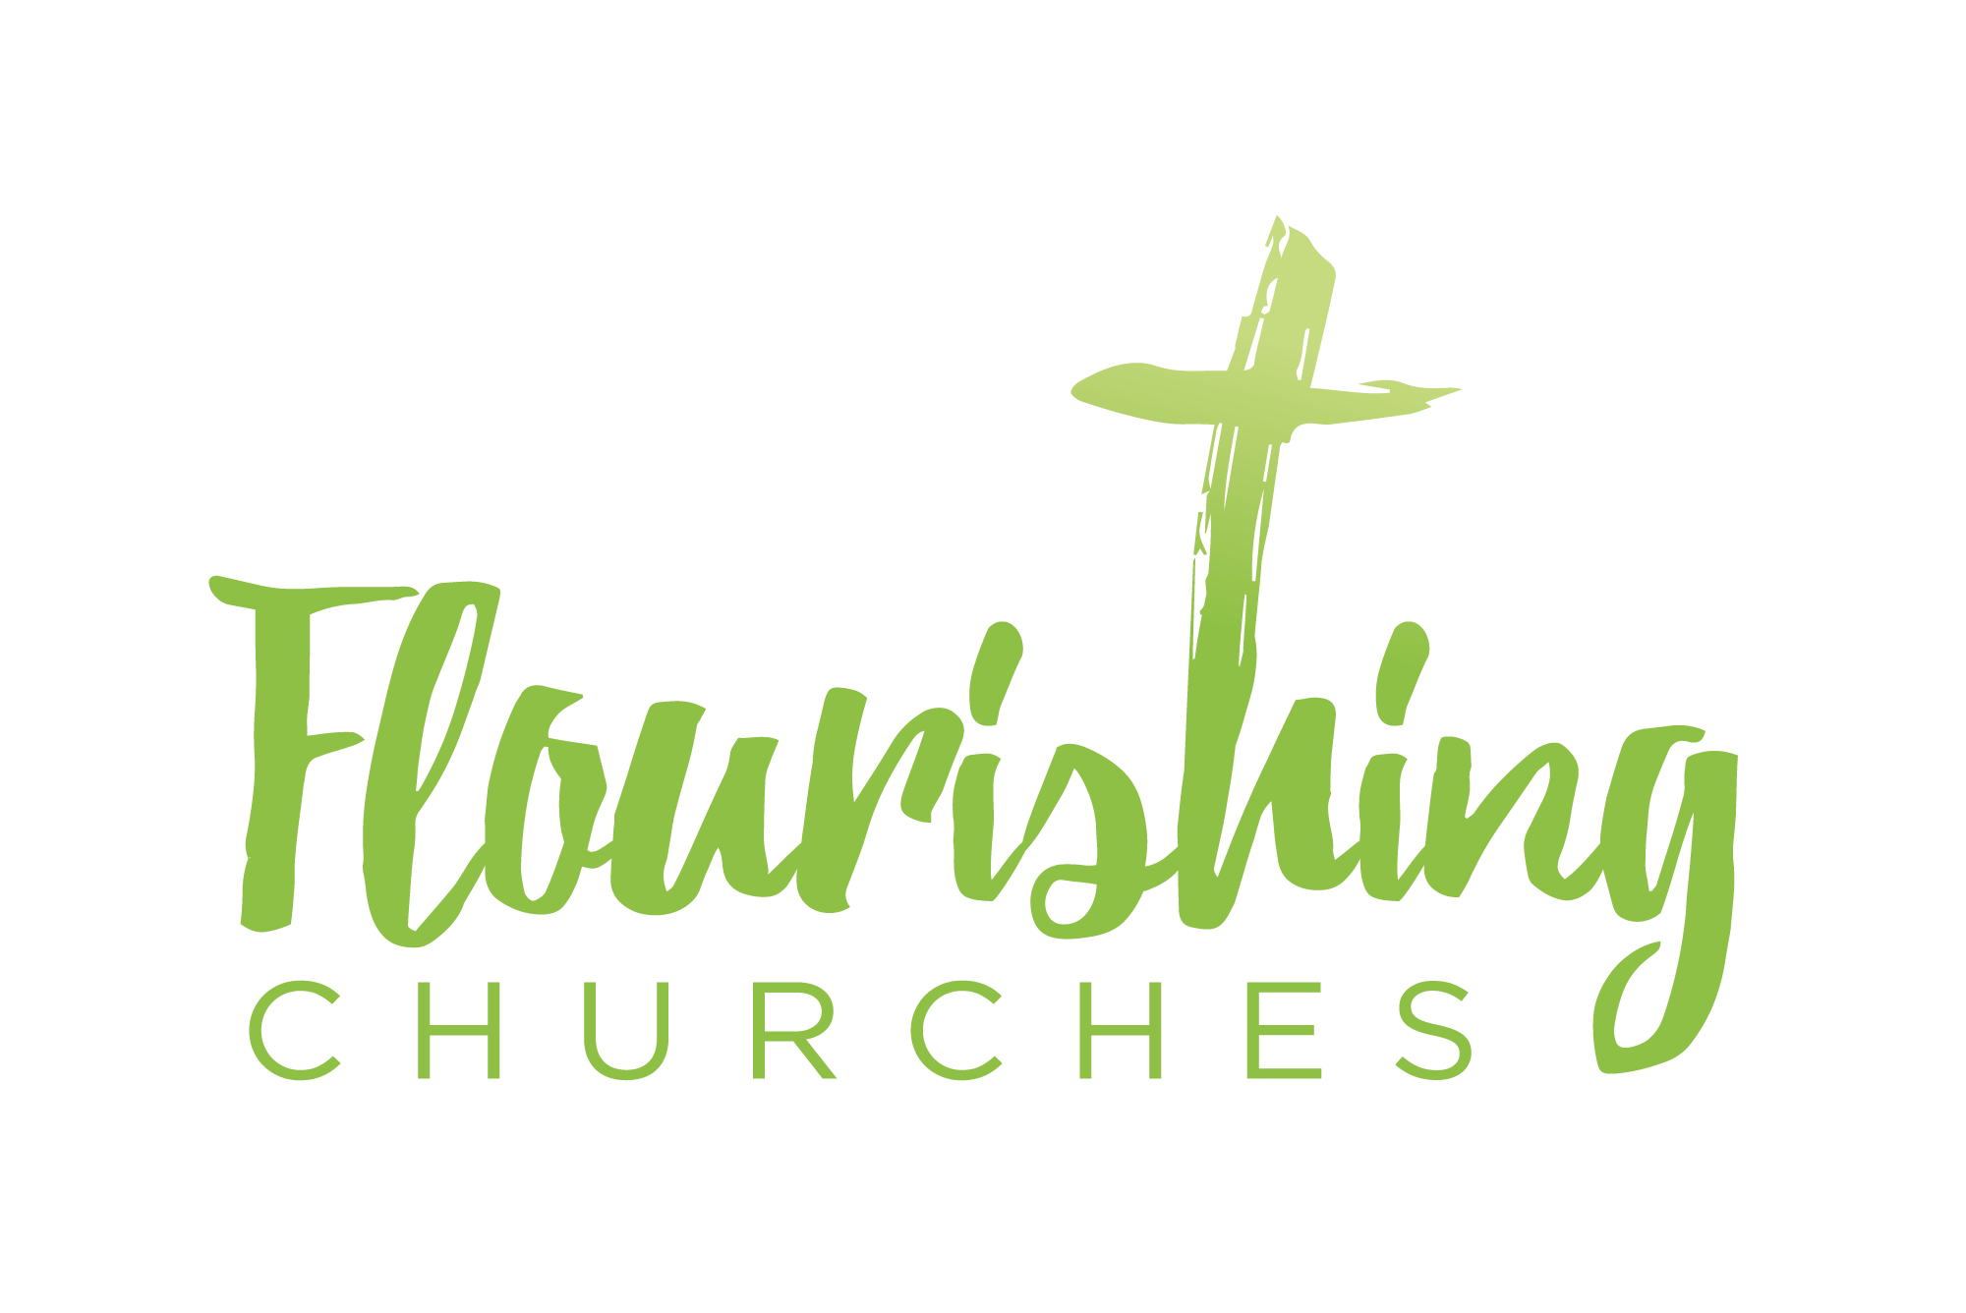
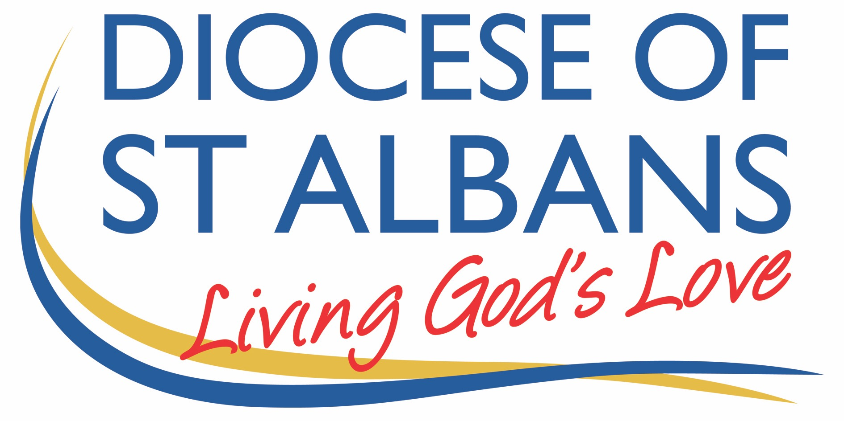

Sunday 22nd November – Christ the King (Stir Up Sunday)

Welcome to Praying Together but Separately
welcome and Introduction

hymn Let all the world in every corner sing:
My God and King!
The heavens are not too high,
his praise may thither fly;
the earth is not too low,
his praises there may grow.
Let all the world in every corner sing:
My God and King.

Let all the world in every corner sing:
My God and King!
The church with psalms must shout,
no door can keep them out;
but above all, the heart
must bear the longest part.
Let all the world in every corner sing:
My God and King!
George Herbert (1593-1633)
gathering before God
I am in the presence of the Living God, Father, Son, and Holy Spirit. Amen.

psalm 95: 1-7 R come let us worship and bow down
O come, let us sing to the Lord;
Let us heartily rejoice in the rock of our salvation.
Let us come into his presence with thanksgiving
And be glad in him with psalms.
For the Lord if a great God
And a great king above all gods. R

In his hand are the depths of the earth and the heights of the mountains are his also.
The sea is his, for he made it,
And his hands have moulded the dry land. R

Come, let us worship and bow down
And kneel before the Lord our Maker.
For he is our God;
We are the people of his pasture and
The sheep of his hand. R

prayers of the Day
God the Father, help us to hear the call of Christ the King
and to follow in his service, whose kingdom has no end;
for he reigns with you and the Holy Spirit,
one God, one glory. Amen

Stir up, Lord, the wills of your faithful people;
that they, plenteously bringing forth the fruit of good works, may by you be plenteously rewarded;
through Jesus Christ our Lord. Amen.

confession
Jesus says, ‘Repent, for the kingdom of heaven is close at hand.’ So let us turn away from sin and turn to Christ, confessing our sins in penitence and faith. Cf Matthew 4:17

The kingdom is yours, but we turn away from your just rule:
Lord have mercy. Lord have mercy

The power is yours, but we trust in our own power and strength:
Christ have mercy. Christ have mercy

The glory is yours, but we fall short of the glory of God:
Lord have mercy. Lord have mercy.

absolution
May God who loved the world so much that he sent his Son to be our Saviour forgive us our sins and make us holy to serve him in the world, through Jesus Christ our Lord. Amen

affirmation of faith
Do you believe and trust in God the Father, source of all being and life, the one for whom we exist?
We believe and trust in Him

Do you believe and trust in God the Son, who took our human nature, died for us and rose again?
We believe and trust in Him.

Do you believe and trust in God the Holy Spirit, who gives life to the people of God and makes Christ known in the world?
We believe and trust in Him

This is the faith of the Church.
This is our faith.
We believe and trust in one God,
Father, Son and Holy Spirit. Amen

Bible Readings:
ezekiel 34: 11-16, 20-24 (on reading sheet)
Ephesians: 1:15 to end (on reading sheet)

Hymn: King of Glory
King of glory, King of peace, I will love thee;
and, that love may never cease, I will move thee.
Thou hast granted my request, thou hast heard me;
thou didst note my working breast, thou hast spared me.
Wherefore with my utmost art I will sing thee,
and the cream of all my heart I will bring thee.
Though my sins against me cried, thou didst clear me;
and alone, when they replied, thou didst hear me.
Seven whole days, not one in seven, I will praise thee;
in my heart, though not in heaven, I can raise thee.
Small it is in this poor sort to enrol thee;
e’en eternity’s too short to extol thee.
George Herbert (1593-1633)

matthew 25: 31-End
‘When the Son of Man comes in his glory, and all the angels with him, then he will sit on the throne of his glory. All the nations will be gathered before him, and he will separate people one from another as a shepherd separates the sheep from the goats, and he will put the sheep at his right hand and the goats at the left. Then the king will say to those at his right hand, “Come, you that are blessed by my Father, inherit the kingdom prepared for you from the foundation of the world; for I was hungry and you gave me food, I was thirsty and you gave me something to drink, I was a stranger and you welcomed me, I was naked and you gave me clothing, I was sick and you took care of me, I was in prison and you visited me.” Then the righteous will answer him, “Lord, when was it that we saw you hungry and gave you food, or thirsty and gave you something to drink? And when was it that we saw you a stranger and welcomed you, or naked and gave you clothing? And when was it that we saw you sick or in prison and visited you?” And the king will answer them, “Truly I tell you, just as you did it to one of the least of these who are members of my family, you did it to me.” Then he will say to those at his left hand, “You that are accursed, depart from me into the eternal fire prepared for the devil and his angels; for I was hungry and you gave me no food, I was thirsty and you gave me nothing to drink, I was a stranger and you did not welcome me, naked and you did not give me clothing, sick and in prison and you did not visit me.” Then they also will answer, “Lord, when was it that we saw you hungry or thirsty or a stranger or naked or sick or in prison, and did not take care of you?” Then he will answer them, “Truly I tell you, just as you did not do it to one of the least of these, you did not do it to me.” And these will go away into eternal punishment, but the righteous into eternal life.’

Some thoughts for further Reflection:

I don’t know how you feel reading this Gospel passage but I for one read it time and again and squirm with guilt and shame as I know very well my actions are not perfect and blameless. I have ignored the homeless in the streets (too many to attend to each one, and my fears come into play too). I have been selfish and tended to my own needs before others and spent, perhaps more than I should on another outfit/handbag/pair of shoes… I have visited prisons and counted the minutes until I could leave as all my buttons were pressed. I have visited hospitals and cared for sick parishioners, but it’s tough. Jesus is asking a lot. And I, for my part, struggle and fall short.

So how can we read this passage and celebrate Christ the King, enthroned in splendour, when the passage given to us, doesn’t pull any punches and leaves us no-where to hide. Added to all this, today is stir up Sunday when our diocese is inviting us to slow down and pray. Pray for the gifts of the Spirit to be stirred within us, as the prayer above invites us to. And you can if you like, spend this afternoon making your Christmas Pudding, as tradition has it, stirring it up, so come Christmas you can enjoy the deliciousness of a matured pudding, bursting with fruit and flavour. Here is a link to all the prayers you might like to take part in this Stir-Up Sunday, knowing you are joining in with hundreds of Christians as we pray for God’s world and church. https://www.stalbans.anglican.org/stir-up-sunday/

So where does this leave us? A desire to pray and enter into Stirring Up our hearts and souls to be ready for Christ? An engagement with our fellow Christians as we join with one another in prayer?

And perhaps a lingering sense of un-ease about judgement and falling short of Jesus’ words from todays Gospel?

So how do we grapple with this equally inspiring and challenging Gospel reading?

Well, as so often with tricky bits of the Bible we need to put it in context as when Jesus said this and the wider themes of surrounding passages. Whilst remembering that today we celebrate Christ the King – the King of All who has humbled himself to be in each of us – not just as a baby in Bethlehem, but Christ resident in each of us. That mutual indwelling of which Paul talks so much. What we do to each other we do to Christ. We are totally accountable, and Christ is totally humble. What right do I have to claim that Christ is in me – but how can I not – when he created me – when he as King created me. Christ is both King of all – ruler of all, mighty and all powerful and yet humble. He is both King on the throne and beggar in the street.
So what do we do about the guilt, the compassion fatigue, the limits of ourselves? How can we still strive for justice, for mercy and God’s Kingdom in our limited way?

Well for me the answer is twofold. Firstly, pray – however you can, whenever you can. In the supermarket buying fair-trade products, in your living rooms as you watch the news. Pray always for justice, for Christ to come again and restore his Kingdom. And secondly, be humble yourself, before the Throne of Grace, be humble, be forgiven by Christ. Be as Christ like as you can – that surely is the mission for us all that we lead lives that mirror the justice and mercy of Christ’s. And see the face of Christ in all whom you meet. Don’t let the guilt weigh you down – the poor will always be with us, and guilt in and of itself can be an indulgence and a distraction. We all have our limits, but Christ does not – limitless King, limitless God, Limitless love. Live in that love and the world will be changed. God’s glory will be realised and you will be doing far more than you realise or know. And remember we are to be stirred to this work – stirred in our souls to be strengthened by the fruits of the Spirit and it is only through the Spirit we can do anything at all.
Rev Kate Peacock

hymn:
Forth in the peace of Christ we go;
Christ to the world with joy we bring;
Christ in our minds, Christ on our lips,
Christ in our hearts, the world's true King.
King of our hearts, Christ makes us kings;
kingship with him, his servants gain;
with Christ, the Servant-Lord of all,
Christ's world we serve to share Christ's reign.
Priests of the world, Christ sends us forth
this world of time to consecrate,
our world of sin by grace to heal,
Christ's world in Christ to re-create.
Prophets of Christ, we hear his Word;
he claims our minds, to search his ways;
he claims our lips, to speak his truth;
he claims our hearts, to sing his praise.
We are his Church, he makes us one;
here is one hearth for all to find;
here is one flock, one Shepherd-King;
here is one faith, one heart, one mind. James Quinn (1919-2010)

prayers
Jesus our exalted Lord has been given all authority.
Let us seek his intercession, that our prayers may be perfected by
his prayer.
Jesus Christ, great high priest, living for ever to intercede for
us: pray for your Church, your broken body in the world …
Lord, hear us.
Lord, graciously hear us.

Jesus Christ, King of righteousness,
enthroned at the right hand of the majesty on high:
pray for the world, and make it subject to your gentle rule …
Lord, hear us.
Lord, graciously hear us.

Jesus Christ, Son of man, drawing humanity into the life of God:
pray for your brothers and sisters in need, distress or sorrow …
Lord, hear us.
Lord, graciously hear us.

Jesus Christ, pioneer of our salvation,
bringing us to your glory through your death and resurrection:
pray for all who are dying,
that they may trust in your promises …
Lord, hear us.
Lord, graciously hear us.

Jesus Christ, Lord of all things,
ascended far above from the heavens and filling the universe:
pray for us who receive the gifts you give us for
work in your service …
Lord, hear us.
Lord, graciously hear us.

Jesus Christ, first-fruits of the new creation,
keep the Church in the unity of the Spirit
and in the bond of peace,
until you bring the whole created order
to worship at your feet;
for you are alive and reign with the Father and the Holy Spirit,
one God, now and for ever. Amen.

a prayer concerning the Coronavirus
God of compassion,
be close to those who are ill, afraid or in isolation.
in their loneliness, be their consolation;
in their anxiety, be their hope;
in their darkness, be their light;
through him who suffered alone on the cross,
but reigns with you in glory,
Jesus Christ our Lord. Amen.

hymn:
King of kings, majesty,
God of heaven living in me,
gentle Saviour, closest friend,
strong deliverer, beginning and end,
all within me falls at your throne.
Your majesty, I can but bow,
I lay my all before you now.
In royal robes I don't deserve
I live to serve your majesty,
I live to serve your majesty.
Earth and heaven worship you,
love eternal, faithful and true,
who bought the nations, ransomed souls,
brought this sinner near to your throne;
all within me cries out in praise.
Chorus

an act of spiritual Communion
My Jesus, I believe that You
are present in the Most Holy Sacrament.
I love You above all things,
and I desire to receive You into my soul.
Since I cannot at this moment
receive You sacramentally,
come at least spiritually into my heart.
I embrace You as if You were already there and unite myself wholly to You.
Never permit me to be separated from You. Amen.
The Lord’s Prayer
Our Father, who art in heaven, hallowed be thy name;
thy kingdom come; thy will be done;
on earth as it is in heaven.
Give us this day our daily bread.
And forgive us our trespasses,
as we forgive those who trespass against us.
And lead us not into temptation; but deliver us from evil.
For thine is the kingdom,
the power and the glory, for ever and ever. Amen.

the peace
To crown all things there must be love,
To bind us all together and complete the whole,
Let the peace of Christ rule in our hearts. Amen.

the blessing
Christ our King make you faithful and strong to do his will, that you may reign with Him in glory:
And the blessing of God Almighty, Father, Son and Holy Spirit be with you and those you love, today and evermore. Amen.

final hymn
All people that on earth do dwell,
sing to the Lord with cheerful voice;
him serve with fear, his praise forth tell,
come ye before him, and rejoice.
The Lord, ye know, is God indeed;
without our aid he did us make;
we are his folk, he doth us feed,
and for his sheep he doth us take.
O enter then his gates with praise,
approach with joy his courts unto;
praise, laud, and bless his name always,
for it is seemly so to do.
For why? the Lord our God is good;
his mercy is for ever sure;
his truth at all times firmly stood,
and shall from age to age endure..
To Father, Son and Holy Ghost,
the God whom heaven and earth adore,
from men and from the angel-host
be praise and glory evermore
To keep up to date with resources and dates from the Flourishing Churches team, please follow us on Facebook: https://www.facebook.com/Flourishing-Churches-St-Albans-Diocese-105528844479183
Also St Albans Diocese Youth Service: https://www.facebook.com/stalbansdys/
And Children’s Ministry St Albans Diocese: https://www.facebook.com/stalbanscme

