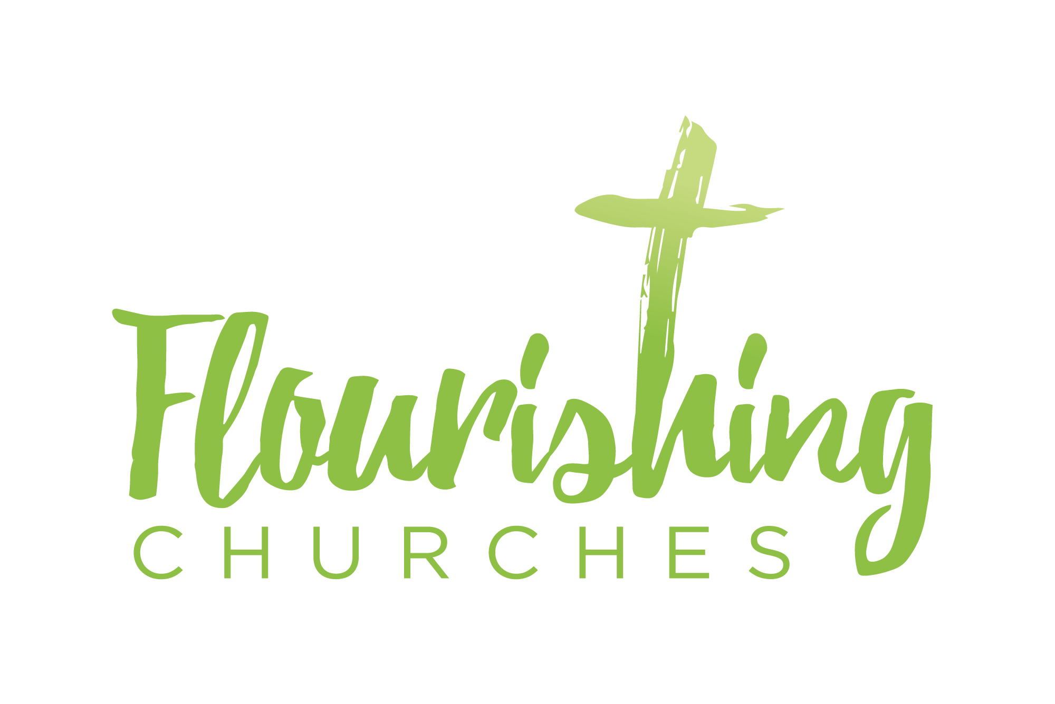

Sunday 13th September 2020: Trinity 14

Welcome to Praying Together but Separately

Introduction and welcome

Hymn: All Creatures of our God and King (St M F)

Prayer of the Day
Merciful God, your Son came to save us and bore our sins on the cross:
may we trust in your mercy and know your love,
rejoicing in the righteousness
that is ours through Jesus Christ our Lord. Amen

Confession
Father eternal, giver of light and grace,
We have sinned against you and against our neighbour,
In what we thought,
In what we have said and done,
Through ignorance, through weakness,
Through our own deliberate fault.
We have wounded you love,
And marred your image in us.
We are sorry and ashamed, and repent of all our sins.
For the sake of your Son Jesus Christ, who died for us,
forgive us all that is past;
and lead us out from darkness to walk as children of light. Amen

absolution
The Lord enrich you with his grace, and nourish you with his blessing: The Lord defend you in trouble and keep you from all evil;
The Lord accept your prayers, and absolve you from your offences,
for the sake of Jesus Christ, our Saviour. Amen

Affirmation of faith
Do you believe and trust in God the Father?
Source of all being and life,
The one for whom we exist?
All: We believe and trust in him.

Do you believe and trust in God the Son,
Who took our human nature,
Died for us and rose again?
All: We believe and trust in him.

Do you believe and trust in God the Holy Spirit,
Who gives life to the people of God
and makes Christ known in the world?
All: We believe and trust in him.

This is the faith of the Church,
All: This is our faith.
We believe and trust in one God,
Father, Son and Holy Spirit. Amen

Bible Readings:
genesis 50: 15-21.
A Reading from the book of Genesis. Joseph Forgives His Brothers
Realizing that their father was dead, Joseph’s brothers said, “What if Joseph still bears a grudge against us and pays us back in full for all the wrong that we did to him?” So they approached Joseph, saying, “Your father gave this instruction before he died, ‘Say to Joseph: I beg you, forgive the crime of your brothers and the wrong they did in harming you.’ Now therefore please forgive the crime of the servants of the God of your father.” Joseph wept when they spoke to him. Then his brothers also wept, fell down before him, and said, “We are here as your slaves.” But Joseph said to them, “Do not be afraid! Am I in the place of God? Even though you intended to do harm to me, God intended it for good, in order to preserve a numerous people, as he is doing today. So have no fear; I myself will provide for you and your little ones.” In this way he reassured them, speaking kindly to them.
Hymn Dear Lord and Father of Mankind (St M F)

matthew 18:21-35
Hear the Gospel of our Lord Jesus Christ according to Matthew
Peter came and said to Jesus, ‘Lord, if another member of the church sins against me, how often should I forgive? As many as seven times?’ Jesus said to him, ‘Not seven times, but, I tell you, seventy-seven times.
‘For this reason the kingdom of heaven may be compared to a king who wished to settle accounts with his slaves. When he began the reckoning, one who owed him ten thousand talents was brought to him; and, as he could not pay, his lord ordered him to be sold, together with his wife and children and all his possessions, and payment to be made. So the slave fell on his knees before him, saying, “Have patience with me, and I will pay you everything.” And out of pity for him, the lord of that slave released him and forgave him the debt. But that same slave, as he went out, came upon one of his fellow-slaves who owed him a hundred denarii; and seizing him by the throat, he said, “Pay what you owe.” Then his fellow-slave fell down and pleaded with him, “Have patience with me, and I will pay you.” But he refused; then he went and threw him into prison until he should pay the debt. When his fellow-slaves saw what had happened, they were greatly distressed, and they went and reported to their lord all that had taken place. Then his lord summoned him and said to him, “You wicked slave! I forgave you all that debt because you pleaded with me. Should you not have had mercy on your fellow-slave, as I had mercy on you?” And in anger his lord handed him over to be tortured until he should pay his entire debt. So my heavenly Father will also do to every one of you, if you do not forgive your brother or sister from your heart.

Sermon by the Dean of St Albans Abbey

Hymn Make me a channel of your peace (Nicholas)

What a challenge for all of us. Let us pray for grace to forgive one another knowing that we too are forgiven and that is God’s great will and desire for us. Not to belittle our mistakes or to stop us learning from our sinfulness, but to say that sin doesn’t have the final word and nor does it define us. Amen.

Prayers
Take a moment to think about a time when someone wronged you or you them. Maybe it was deeply personal or maybe it was more of a corporate sin – a terror attack or a miscarriage of justice.

Examine that moment in your heart – what were your thoughts and feelings? Maybe those feelings were mentioned in the parable above? Anger, pity, mercy, judgement? Or maybe you had other feelings; frustration, disappointment, pride, despair?

Offer those thoughts to God and seek reconciliation over them.

intercessions:
In faith we pray to the Lord. We pray to you our God

That this day may be holy, peaceful and full of your presence:
In faith we pray. We pray to you our God

That the work we do and the people we meet today
May bring us closer to you;
in faith we pray. We pray to you our God

That we may be forgiven our sins and failures;
In faith we pray. We pray to you our God

That we may hear and respond to your call to peace and justice:
In faith we pray. We pray to you our God

That you will sustain the faith and hope of those who are lonely, oppressed and anxious.
In faith we pray. We pray to you our God

That you will strengthen us in your service, and fill our hearts with longing for your kingdom;
In faith we pray. We pray to you our God

God of mercy,
You know us and love us and hear our prayer:
Keep us in the eternal fellowship of Jesus Christ our Saviour, Amen

Let us take a moment to pray this prayer of St Francis:

Lord, make me an instrument of your peace.
Where there is hatred, let me bring love.
Where there is offence, let me bring pardon.
Where there is discord, let me bring union.
Where there is error, let me bring truth.
Where there is doubt, let me bring faith.
Where there is despair, let me bring hope.
Where there is darkness, let me bring your light.
Where there is sadness, let me bring joy.
O Master, let me not seek as much
to be consoled as to console,
to be understood as to understand,
to be loved as to love,
for it is in giving that one receives,
it is in self-forgetting that one finds,
it is in pardoning that one is pardoned,
it is in dying that one is raised to eternal life. Amen
a prayer concerning the coronavirus
God of compassion, be close to those who are ill, afraid or in isolation. In their loneliness, be their consolation; in their anxiety, be their hope; in their darkness, be their light; through him who suffered alone on the cross, but reigns with you in glory, Jesus Christ our Lord. Amen.
The Lord’s Prayer
Our Father, who art in heaven, hallowed be thy name;
thy kingdom come; thy will be done; on earth as it is in heaven.
Give us this day our daily bread. And forgive us our trespasses,
as we forgive those who trespass against us.
And lead us not into temptation; but deliver us from evil.
For thine is the kingdom, the power and the glory,
for ever and ever. Amen
Musical chorus (Nicholas)
An Act of Spiritual Communion. My Jesus, I believe that You are present in the Most Holy Sacrament, I love You above all things, and desire to receive You into my soul. Since I cannot at this moment receive You sacramentally, come at least into my heart. I embrace You as if You were already there and unite myself wholly to You. Never permit me to be separated from You. Amen
the blessing: May God who clothes the lilies and feeds the birds of the sky, who leads the lambs to pasture and the deer to water, who multiplied loaves and fishes and changed water into wine, lead us, feed us, multiply us,
And change us to reflect the glory of our Creator now and through all eternity, and the blessing of God the Father, God the Son and God the Holy Spirit be with you and those you love, for now and ever more. Amen

Go in Peace to love and serve the Lord.. in the name of Christ, Amen

Hymn: Praise my soul the king of heaven (Nicholas)

